Softuniada 2019

Rooks
On a rectangular chess board with X rows and Y columns, N rooks should be placed in such a way, so that each of them is attacked by at most 1 other rook. One rook is attacked by another rook, if they are placed on the same row, or on the same column, and there are no other rooks between them.
Write a program, which finds the count of all possible ways that these N rooks can be placed on the X / Y chess board, so that they cover the conditions specified above. Due to the fact, that the answer may be a very big number, always print the remainder of the division of the actual count with 1,000,001.

Input
The input consists of 3 input lines:
- On the first line you will receive X – the rows of the chessboard
- On the second line you will receive Y – the columns of the chessboard
- On the third line you will receive N – the count of rooks that should be placed on the chessboard

Output
The output should consist of a single line, containing the remainder of the division of the desired count, with 1,000,001.

Constraints
- X, Y and N will be integers in range [1, 100].
- Allowed working time / memory: to be defined.

Examples
Input | Output | Comment
4  6  2 | 276 | There are only 2 rooks here and all ways they can be placed are valid. The answer is: (4 * 6) * (4 * 6 - 1) / 2 = 276.
2  3  3 | 6 | 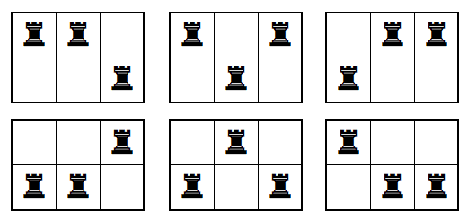
1  100  3 | 0 | We cannot place 3 rooks on one row.
9  6  10 | 340200
98  99  100 | 951454 | The actual count is:  477162926599652378693202655573012530649120970956713215  413593915639833497991226651408072530190805115228714441  793077869034810249957308229677723184016455888816349376  99689344614655096884769587200000000000000000000000

